PORT AUTHORITY DEMAND ANALYTICS

This report analyzes passenger demand and forecasts future usage to support the Port Authority’s staging capacity and operational planning for the 2026-2030 period.

Project Overview
- Consolidated 160+ weekly Excel worksheets into a single, cleaned, and validated dataset.
- Created structured analytical tables including date, carrier, and weekly passenger and departure totals.
- Built time-series forecasting models (ARIMA) to project passenger demand for 2026-2030.
- Developed Power BI dashboards to visually answer all five project questions.
- Integrated weather, holiday, and seasonal indicators to enhance demand analysis.
- Conducted carrier-level forecasts and year-over-year comparisons, including pre-COVID (2019) benchmarks.
- Synthesized analytical results into business insights and actionable recommendations.

Question 1: Passenger Forecast for Temporary Staging Facilities (2026-2030)
How many passengers are expected to use the Port Authority Bus Terminal’s temporary staging facilities between 2026 and 2030?
Figure 1 shows weekly passenger volumes at the Port Authority Bus Terminal from 2020 to 2025, together with the forecast through 2030 based on the ARIMA model. The historical data reflects a clear recovery after the pandemic, with passenger numbers rising steadily and settling around 90,000 to 105,000 passengers per week in the 2024-2025 period.
The shaded area represents the forecasted passenger demand for 2026-2030 and includes confidence intervals to show the range of possible outcomes. The results suggest that passenger demand is expected to continue growing, with regular seasonal ups and downs. Although the uncertainty increases further into the forecast period, the overall trend remains upward, indicating sustained growth in terminal usage.

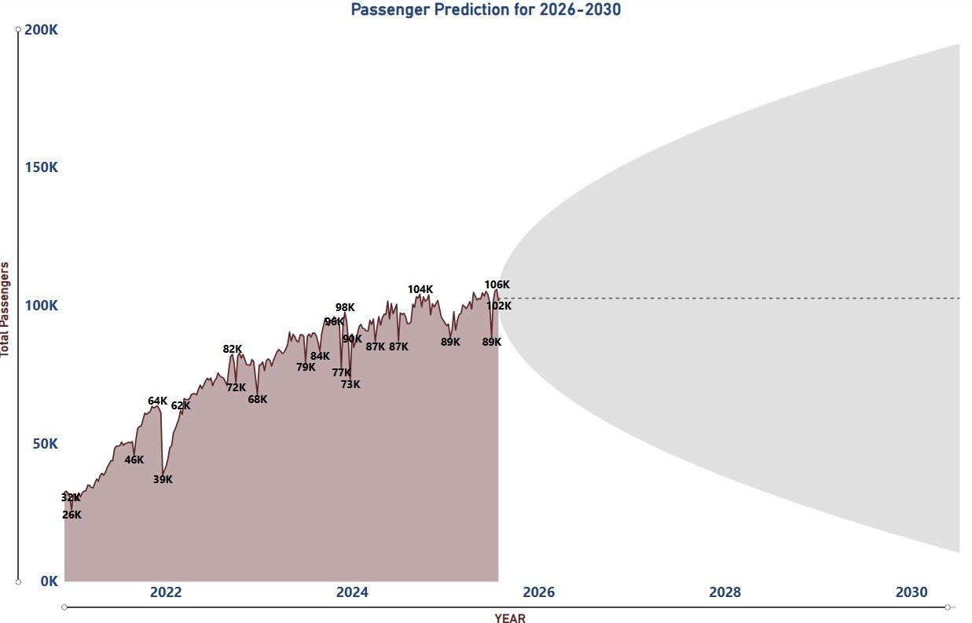
Figure 1. Historical Passenger Trends and Forecast for 2026-2030
Figure 2 presents the annual passenger forecasts for the 2026-2030 period based on the ARIMA model. The results show a steady increase in total passengers over time, with annual demand rising from approximately 5.8 million in 2026 to about 9.1 million by 2030.
The error bars represent the 95% confidence intervals, highlighting the range of possible outcomes for each year. While the forecast uncertainty widens in later years, the overall pattern points to consistent growth. These annual estimates provide a clear basis for planning temporary staging capacity, staffing levels, and operational resources over the forecast horizon.
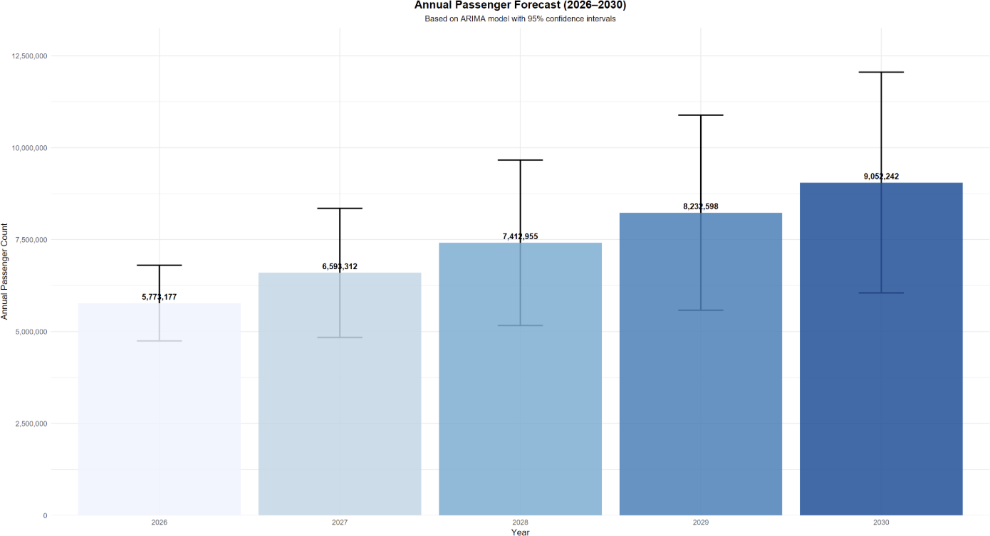

Figure 2. Annual Passenger Forecast for 2026-2030

Question 2: Key Factors Driving Passenger Demand
What are the most important factors in predicting weekly passenger volumes at the bus terminal?
Figure 3 shows the relative importance of key variables used to predict weekly passenger demand, based on a multiple regression model ranked by absolute t-values. The results clearly indicate that passenger volume in the previous week is by far the strongest predictor of current demand, highlighting strong short-term continuity in travel behavior.
Seasonal effects, represented by the month of the year, also play an important role, reflecting recurring patterns throughout the year. Weather-related factors, such as average weekly temperature, show a moderate but meaningful influence, while variables like holiday weeks and weekly precipitation have smaller and less consistent effects. Overall, the results suggest that historical demand patterns and seasonality are the primary drivers of weekly passenger volumes, while external factors mainly act as secondary influences.
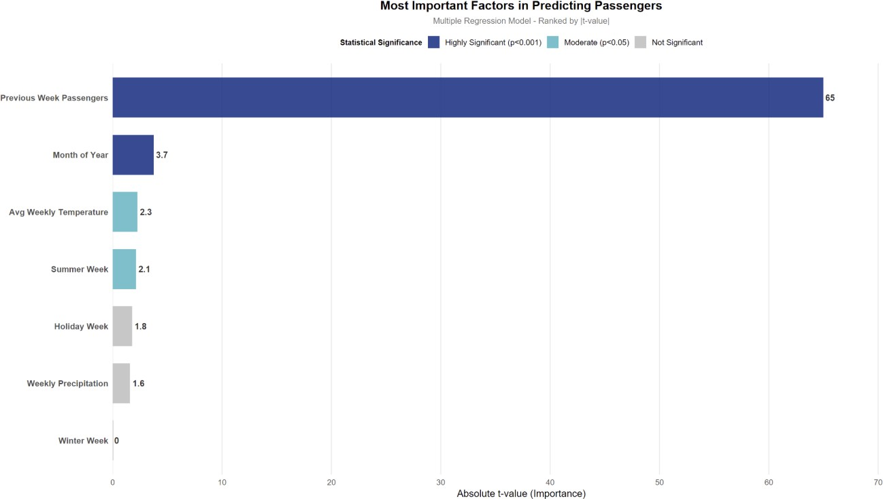
Figure 3. Most Important Factors Driving Weekly Passenger Demand

Question 3: Passenger Forecast by Individual Carrier (2026-2030)
How is passenger demand expected to change for each carrier between 2026 and 2030?
Figure 4 shows historical weekly passenger volumes by individual carrier from 2021 to 2025. NJ Transit clearly dominates overall passenger activity and shows a strong recovery after the pandemic, reaching weekly levels close to 85,000-90,000 passengers by 2024-2025. Other carriers operate at significantly lower but relatively stable levels, providing a baseline for understanding the distribution of passenger demand across carriers prior to forecasting.

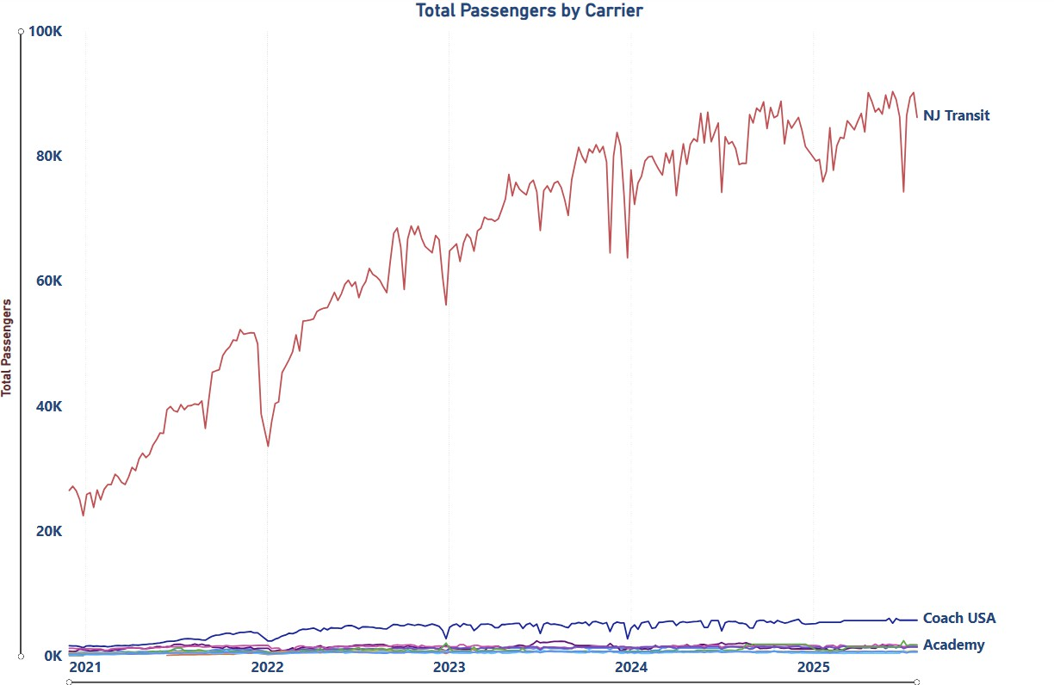

Figure 4. Historical Weekly Passenger Trends by Carrier (2021-2025)

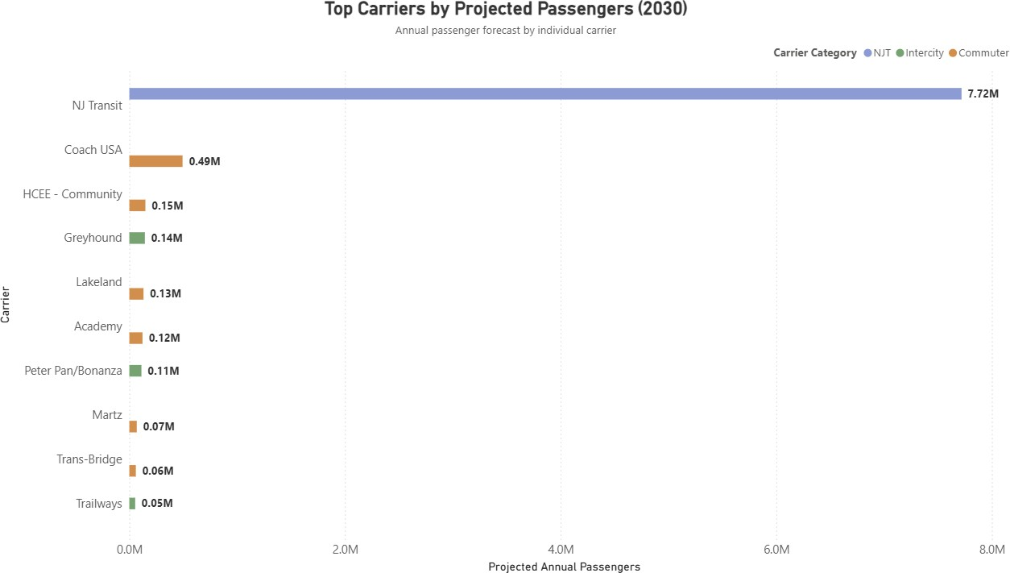

Figure 5. Projected Annual Passenger Demand by Individual Carrier (2030)

Figure 5 presents the projected annual passenger demand by individual carrier for the year 2030, based on carrier-level forecasts derived from the overall passenger projections. The results show that passenger demand is highly concentrated among a small number of carriers. NJ Transit is expected to remain the dominant operator, serving approximately 7.7 million passengers, which represents the majority of total terminal demand.
Other carriers are projected to operate at significantly lower volumes. Coach USA is expected to serve about 0.49 million passengers, while carriers such as HCEE - Community, Greyhound, Lakeland, and Academy are each projected to handle between 0.1 and 0.15 million passengers annually. Overall, the forecast indicates that future passenger growth will continue to be driven primarily by NJ Transit, with smaller but stable contributions from commuter and intercity carriers.

Question 4: Busiest Times for Staging Facilities (2026-2030)
What are the busiest weeks, months, and years for the bus terminal’s staging facilities between 2026 and 2030?
Figure 6 shows average weekly passenger volumes by week number for the 2020-2025 period. Across all years, passenger demand generally increases from the beginning of the year toward the middle and later weeks, indicating a clear seasonal pattern. Higher passenger levels are typically observed during the late summer and fall weeks.
Some declines appear in the final weeks of the year, particularly in recent years. These drops are influenced by short-term
factors such as holidays, reduced service schedules, and incomplete or irregular year-end data rather than a consistent long-term seasonal decline. Overall, this historical view helps identify recurring weekly demand patterns that inform staging facility planning.
This historical pattern is used to provide context for the forecasted busiest weeks shown in Figure 8, rather than to directly predict future peak periods.
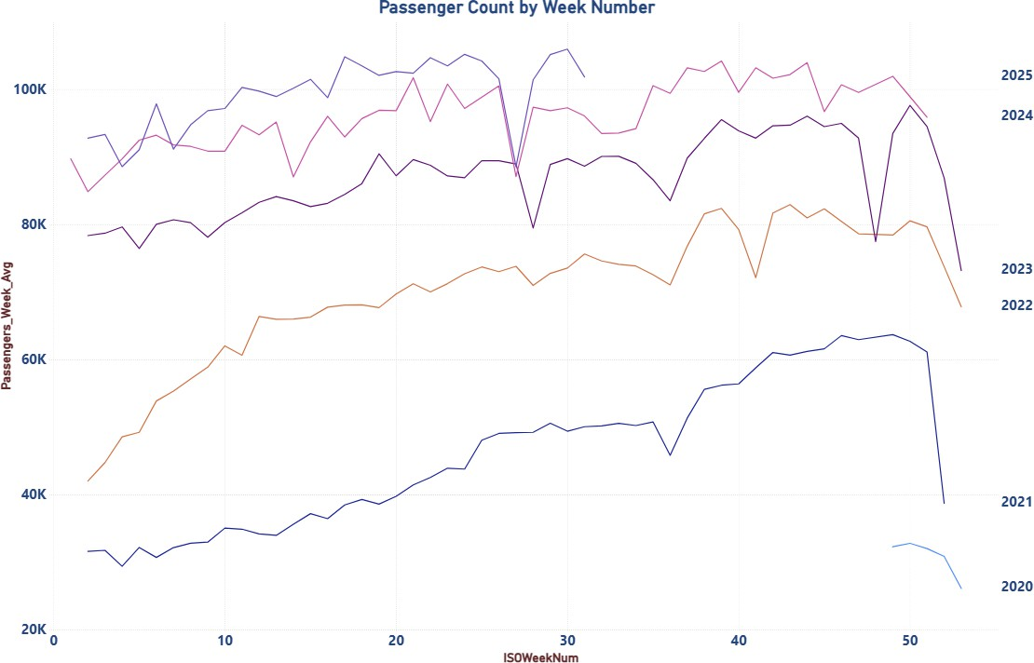

Figure 6. Historical Weekly Passenger Patterns by Week Number (2020-2025)

Figure 7 shows historical passenger demand aggregated by month for the 2020-2025 period. Overall, passenger volumes tend to be higher during the late summer and fall months, particularly August through October, while early-year months generally show lower demand.
The number of visible bars varies across months because data for 2020 does not include the full year and 2025 contains partial-year data only. As a result, some months are missing observations for those years. Despite this limitation, the chart still highlights consistent seasonal patterns across the years with complete data, providing useful context for identifying historically busier months.
These historical monthly patterns serve as contextual input and are complemented by the forecasted monthly demand presented in Figure 8.

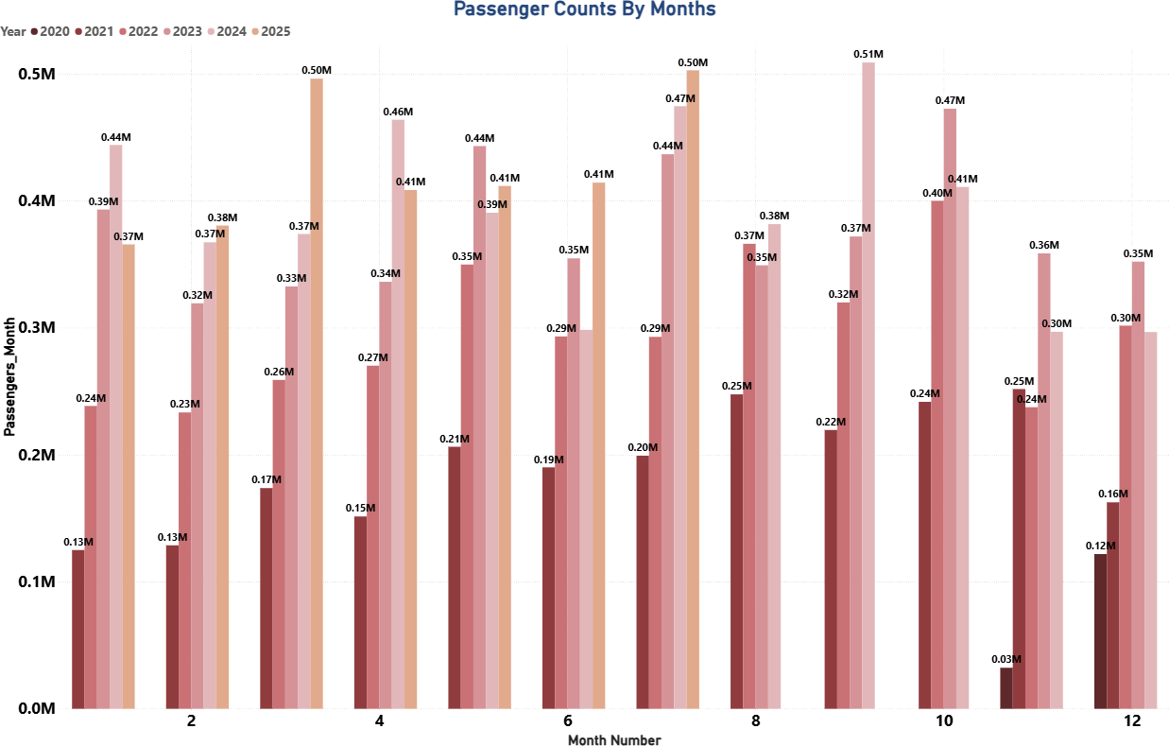

Figure 7. Historical Passenger Demand by Month (2020-2025)

Figure 8 summarizes the forecasted busiest periods for the bus terminal staging facilities between 2026 and 2030, combining yearly totals, average monthly demand, and the top ten busiest weeks. The results indicate a steady increase in passenger volumes over time, with 2030 projected to be the busiest year, reaching approximately 9.05 million passengers.
On a monthly basis, higher average demand is expected during the fall months, particularly October, November, and December, confirming seasonal patterns observed in historical data. Weekly forecasts show that the busiest weeks are concentrated toward the end of the year, especially between Weeks 43 and 52, with peak weekly demand exceeding 180,000 passengers in some cases. These findings suggest that staging capacity and operational planning should prioritize late-year periods as overall passenger demand continues to grow.

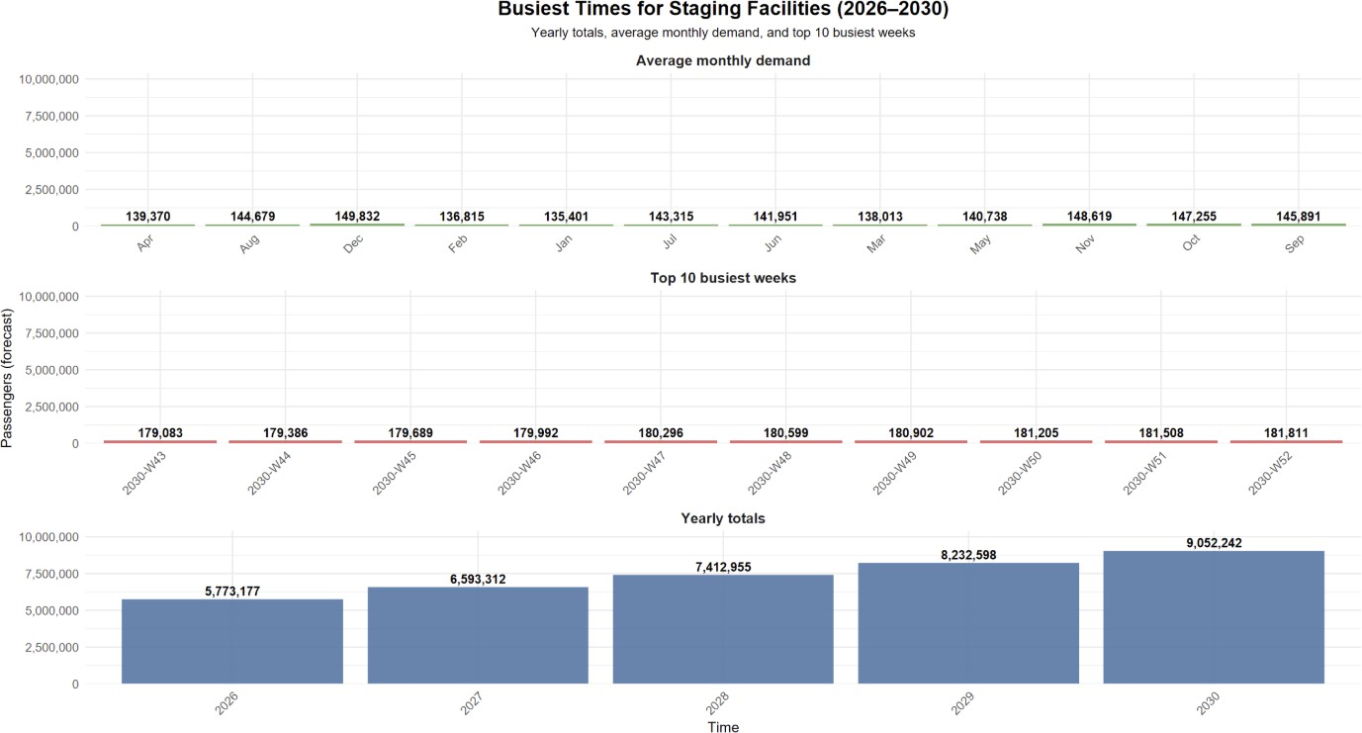

Figure 8. Busiest Times for Staging Facilities (Forecast: 2026-2030)
While historical weekly data shows occasional declines toward the end of the year, particularly in recent post-pandemic periods, these patterns reflect data limitations and short-term operational factors rather than structural demand trends. The
forecasting model emphasizes long-term growth and seasonality, resulting in higher projected passenger volumes during late-year weeks as overall demand increases.

Question 5: Usage Recovery Compared to 2019 (Pre-COVID Baseline)
How does current passenger usage compare to 2019, the last year before COVID-19?
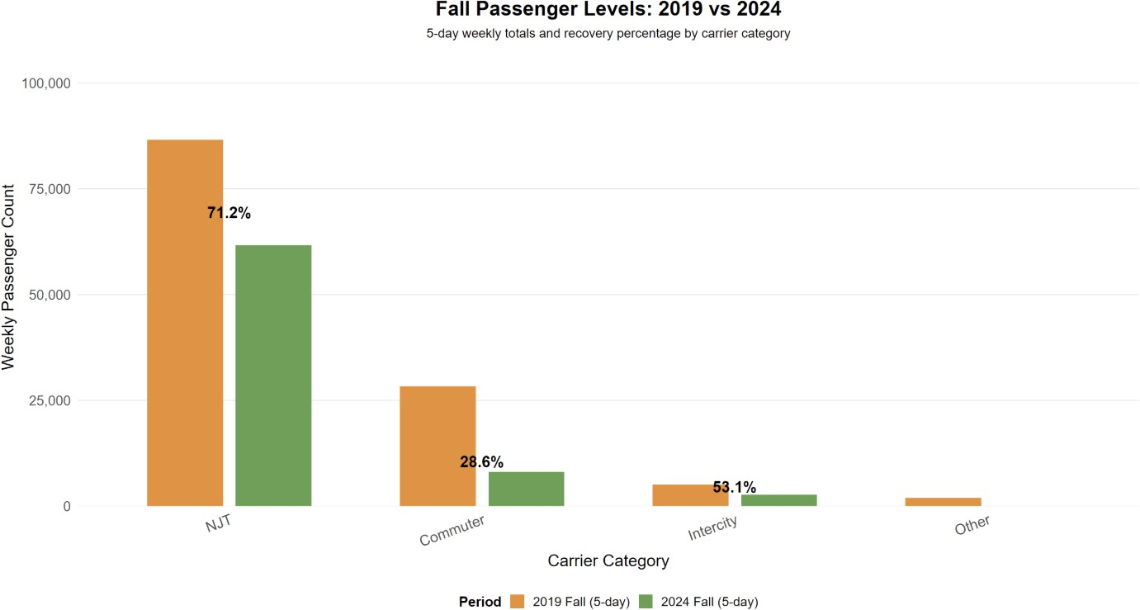
Figure 9. Fall Passenger Levels: 2019 vs 2024 (5-Day Weekly Totals)

Figure 9 compares average 5-day weekly passenger volumes in Fall 2019 (pre-COVID) with Fall 2024, segmented by carrier category. The results show that overall ridership has not yet fully recovered to pre-pandemic levels, with recovery patterns varying significantly across carrier types.
NJ Transit shows the strongest recovery, reaching approximately 71% of its 2019 Fall passenger levels, indicating a relatively robust return of commuter demand. In contrast, commuter carriers have recovered only about 29% of their pre-COVID volumes, suggesting a slower and more uneven recovery in this segment. Intercity carriers show a moderate recovery at around 53%, while the Other category remains well below pre-pandemic levels.
Overall, these results indicate that while passenger demand is steadily recovering, full return to 2019 levels has not yet been achieved, and recovery dynamics differ substantially by carrier category.

Dashboard Overview
The Power BI dashboards were designed to clearly communicate the answers to all five project questions. Each visual is directly linked to a specific business question and allows decision-makers to explore passenger trends, forecasts, and recovery patterns without requiring additional data imports.
The dashboards include visuals for total passenger forecasts, key demand drivers, carrier-level projections, busiest periods for staging facilities, and recovery comparisons with pre-COVID levels.

Limitations and Assumptions
- Limited pre-COVID baseline (only Fall 2019 available)
- Partial data for 2020 and 2025
- No event-level data
- Some carriers have sparse data
- Forecast assumes historical trends continue
- Some seasonal indicators have low statistical significance

Recommendations to the Port Authority
Based on the analysis of historical trends, forecasting results, and recovery patterns, the following recommendations are proposed to support effective planning and decision-making for the Port Authority.
First, staging capacity and operational planning should strongly focus on late-year peak periods, particularly October through December (Weeks 43-52). Forecast results indicate that passenger demand will continue to increase each year through 2030, with the highest pressure on staging facilities occurring toward the end of the year. To manage this growth, the Port Authority should plan for flexible staffing levels, temporary infrastructure adjustments, and dynamic scheduling during these peak
periods.
Second, special attention should be given to NJ Transit, which consistently carries the largest share of passengers and is
projected to remain the dominant carrier through 2030. Because NJ Transit drives the majority of terminal demand, even small disruptions in its operations can have a disproportionate impact on congestion and staging capacity. The Port Authority should therefore prioritize NJ Transit-focused planning, including dedicated staging areas, prioritized gate assignments, and closer
coordination on schedule changes, especially during peak weeks.
Third, the Port Authority can improve overall operational efficiency by adopting a more carrier-specific resource allocation strategy. Rather than distributing resources evenly across all carriers, staging space, staffing, and operational support should

be scaled according to passenger volume. This targeted approach can help reduce bottlenecks, improve passenger flow, and avoid over-allocation of resources to lower-volume commuter or intercity services.
In addition, to improve data accuracy, reduce manual errors, and support scalable forecasting, the Port Authority should consider strengthening data governance through a centralized relational database design. Given the current reliance on integrating more than 160 weekly Excel files, transitioning to standardized database tables with built-in validation checks would improve data consistency, streamline ETL processes, and provide a more reliable foundation for ongoing analytics and forecasting.
Looking ahead, future analyses would benefit from the collection of additional and more detailed data. In particular, incorporating event-level data (such as concerts, sports events, or major public gatherings), service disruption records, and fare or ticket price information would help explain short-term demand spikes and improve forecast accuracy. More granular carrier-level operational data, including frequency changes and capacity adjustments, would further strengthen planning efforts.
Finally, the Port Authority should consider integrating exogenous factors into ongoing forecasting and monitoring activities. Weather extremes, major holidays, regional economic conditions, and evolving work patterns (such as remote or hybrid work) may influence travel behavior and should be evaluated alongside historical ridership data. Regularly updating forecasting
models with new data and external indicators will allow the Port Authority to respond proactively to demand changes and better support long-term growth.

